# Hands-on Lab : Getting Started with Watson Studio

Estimated time needed: 20 minutes

IBM Watson Studio provides you with the environment and tools to solve problems by collaboratively working with data. You can choose the tools you need to analyze and visualize data, to cleanse and shape data, to ingest streaming data, or to create and train machine learning models.

# Software Used in this Lab

In this lab, you will get started with IBM Watson Studio Lite plan service through IBM Cloud as this is available at no charge for 1 authorized user with 50 capacity unit-hours monthly limit. Lite plan services are deleted after 30 days of inactivity.

# Objectives

After completing this lab, you will be able to:

* Create an Instance of Watson Studio
* Login to IBM Cloud Pak for Data to use Watson Studio
* Creating a Project
* Adding a Jupyter Notebook to the Project

# Exercise 1: Create an Instance of Watson Studio/ Login to IBM Cloud Pak for Data to use Watson Studio

In this exercise, you will create an instance of Watson Studio and login to IBM Cloud Pak for Data to use Watson Studio.

## Task A: Create an Instance of Watson Studio

1. [Click here](https://cloud.ibm.com/catalog/services/watson-studio?utm_medium=Exinfluencer&utm_source=Exinfluencer&utm_content=000026UJ&utm_term=10006555&utm_id=NA-SkillsNetwork-wwwcourseraorg-SkillsNetworkCoursesIBMDA0321ENSkillsNetwork21426264-2021-01-01) to go to the IBM Cloud Watson Studio service instance creation page.
2. Select Lite plan and click Sign up to create.  
   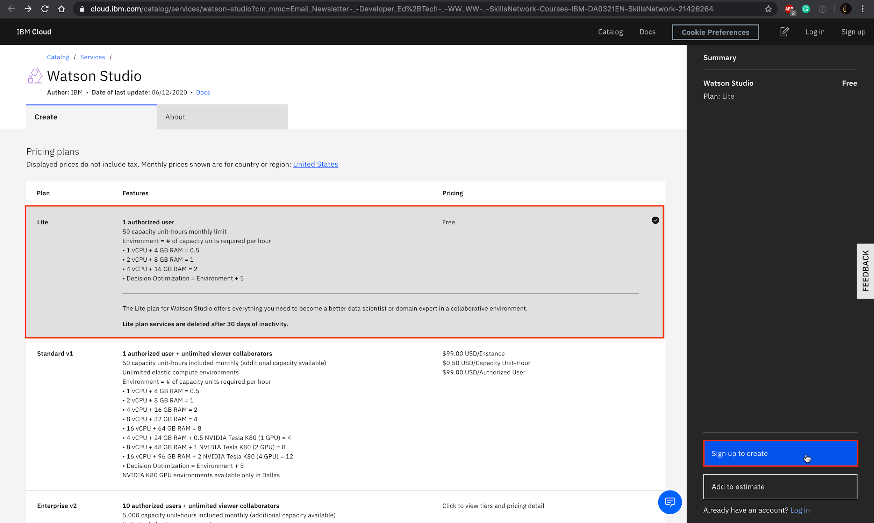
   * If you don't have an IBM Cloud account, fill out section 1,2 and 3 under Create an account and click Create account.
   * If you already have an IBM Cloud account, click Login in and enter your IBMid and password.
3. 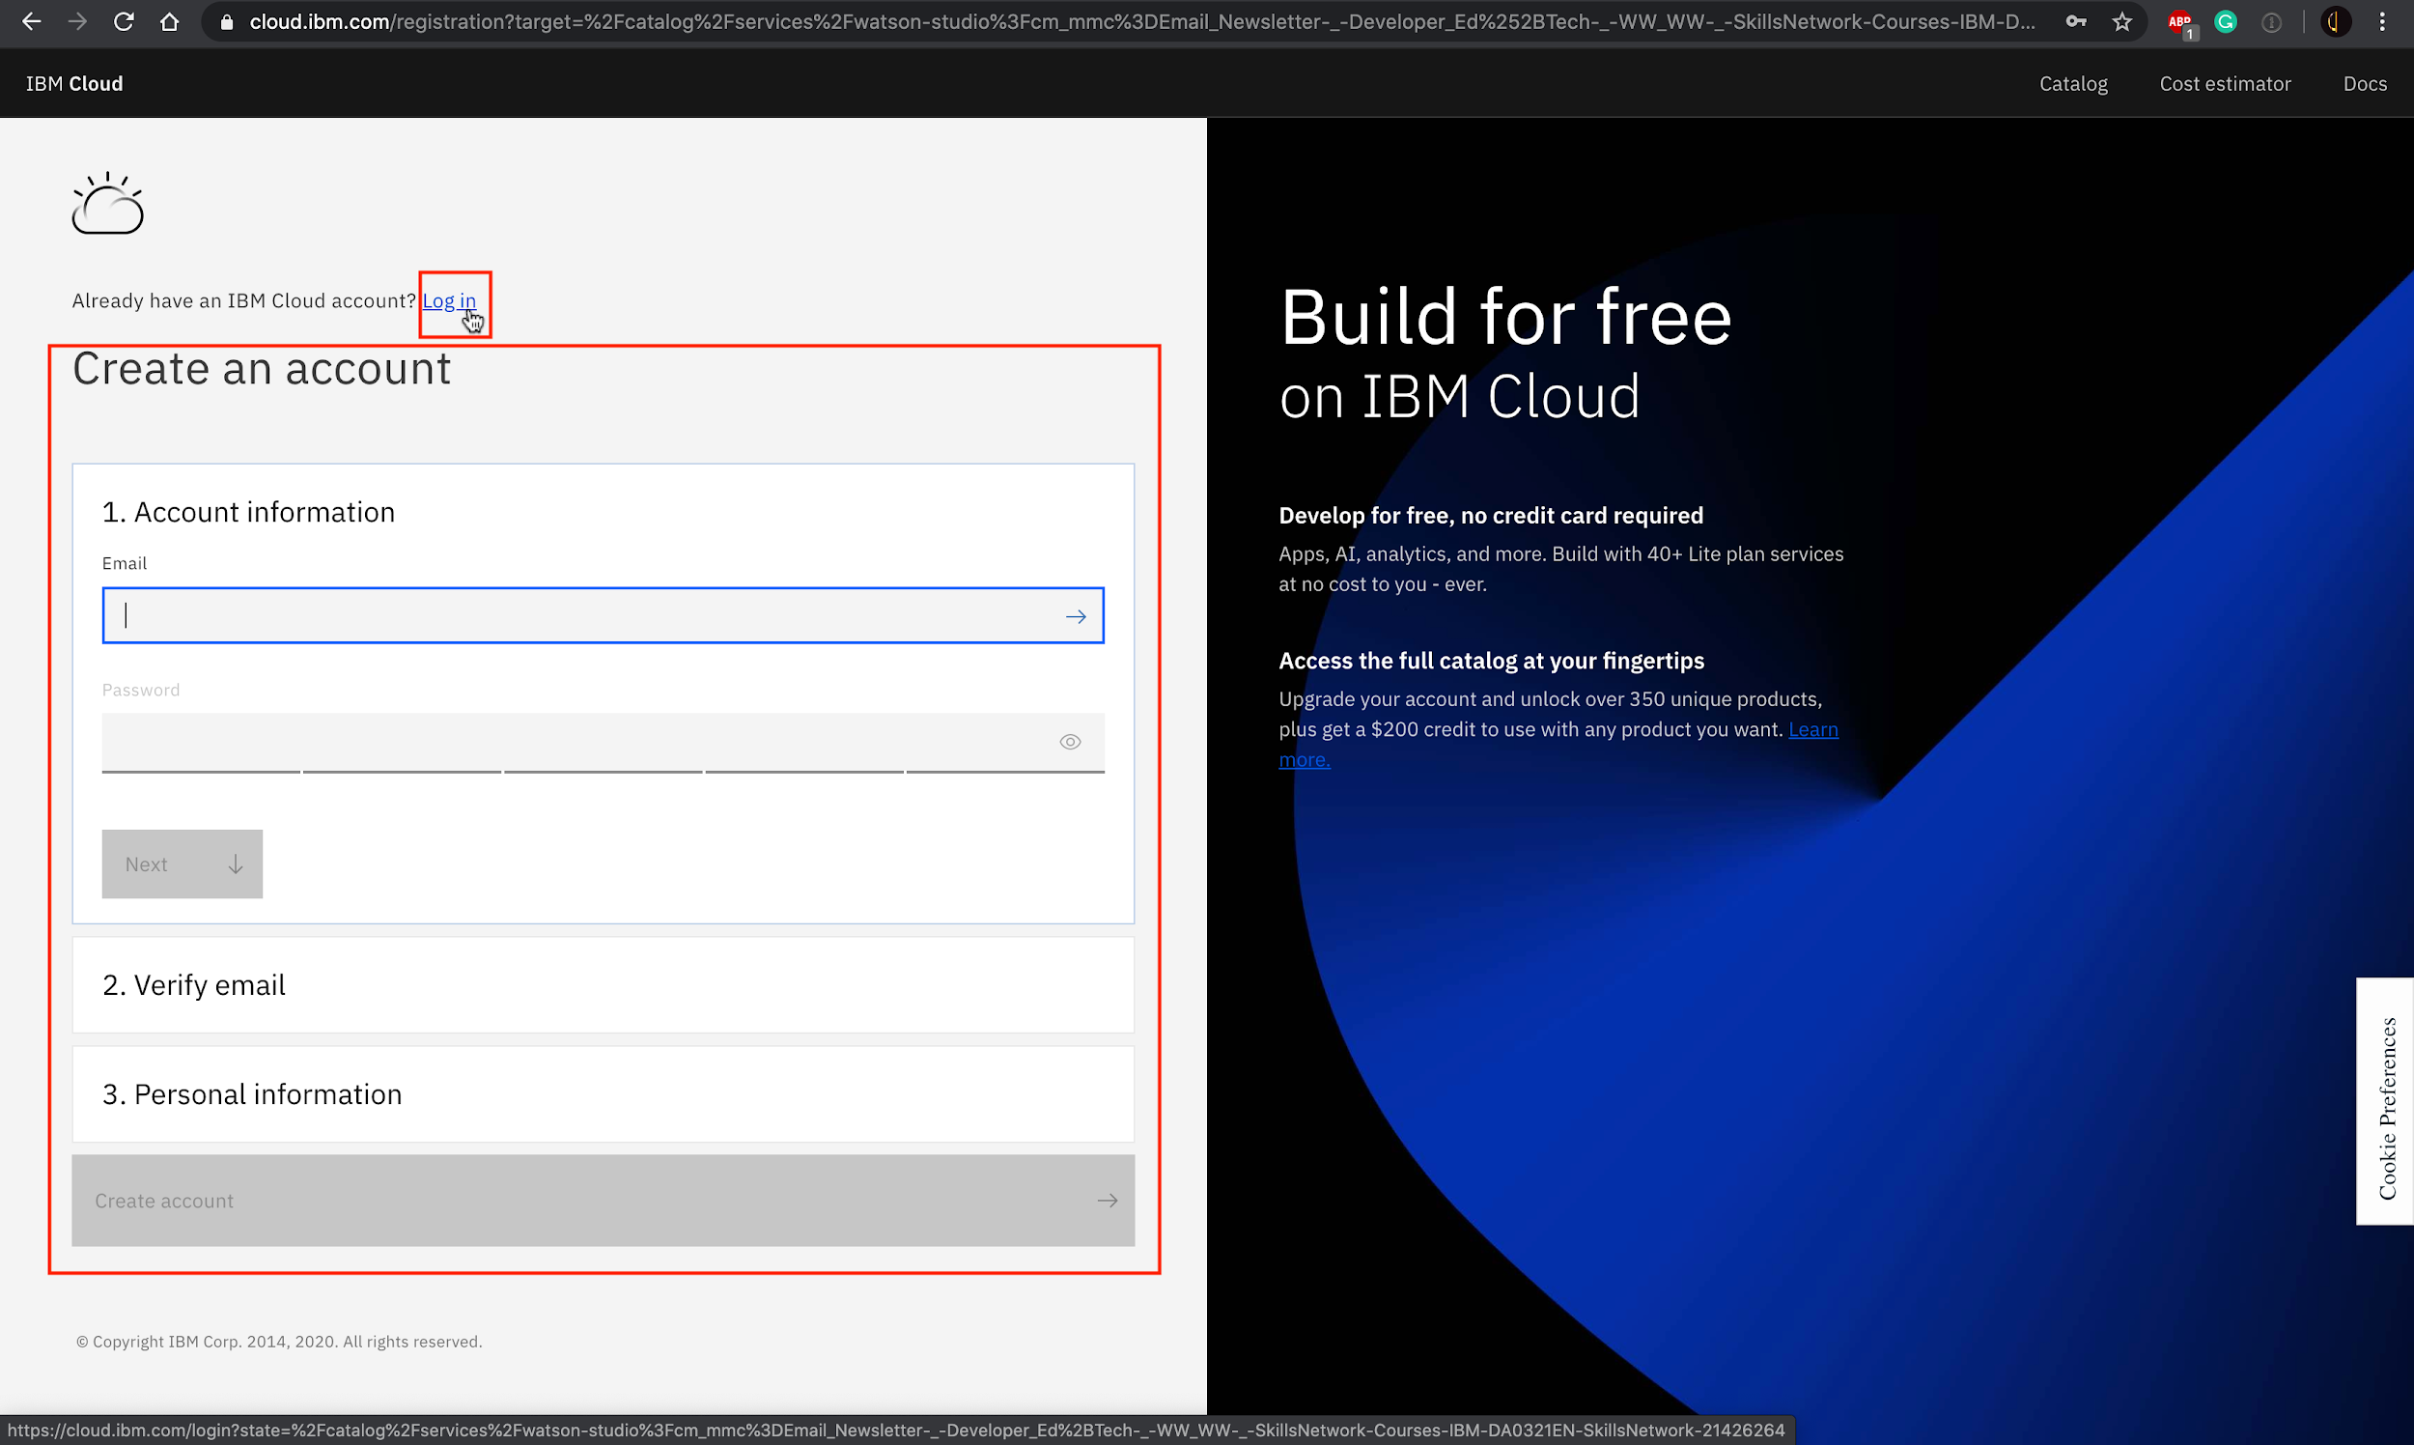
4. You will be redirected back to Watson Studio instance creation page. Select a region matching the region of your IBM Cloud account. Click Create.  
   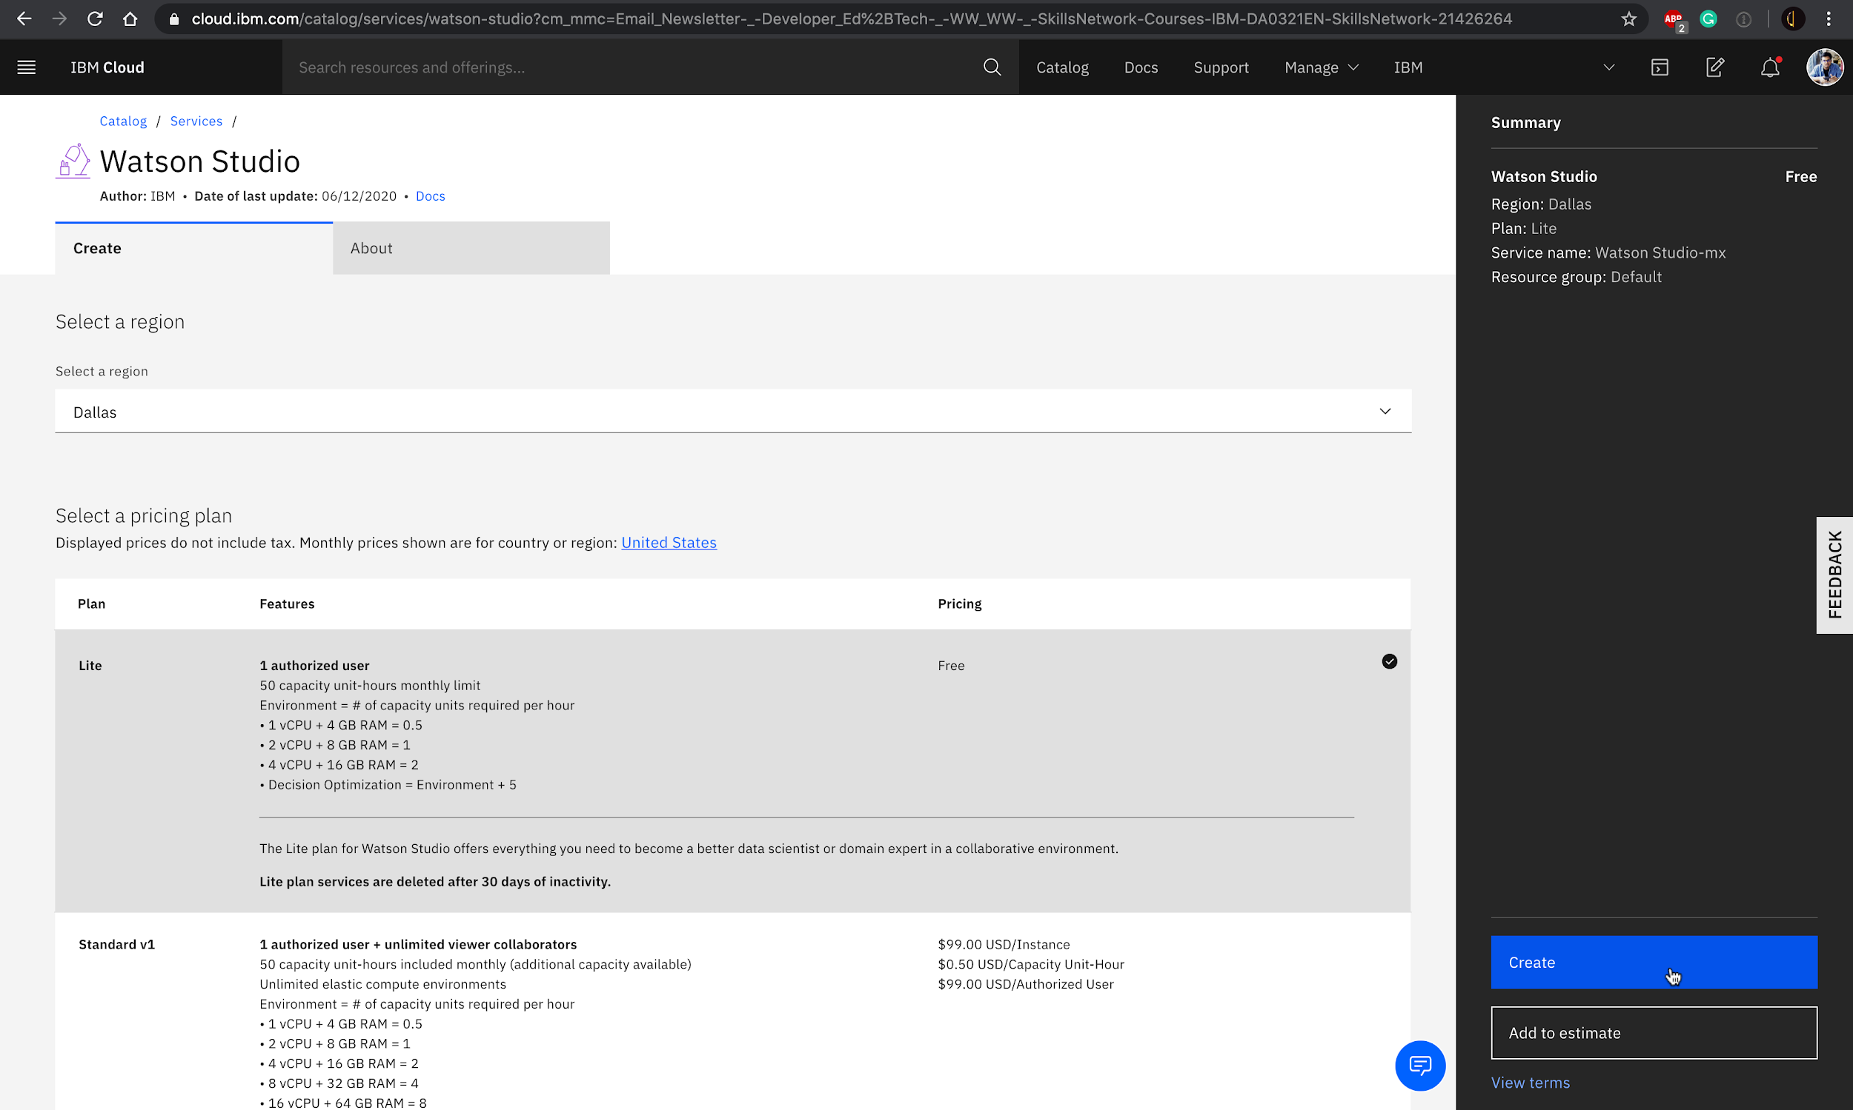
5. You have successfully created Watson Studio service instance. Click Get Started.  
   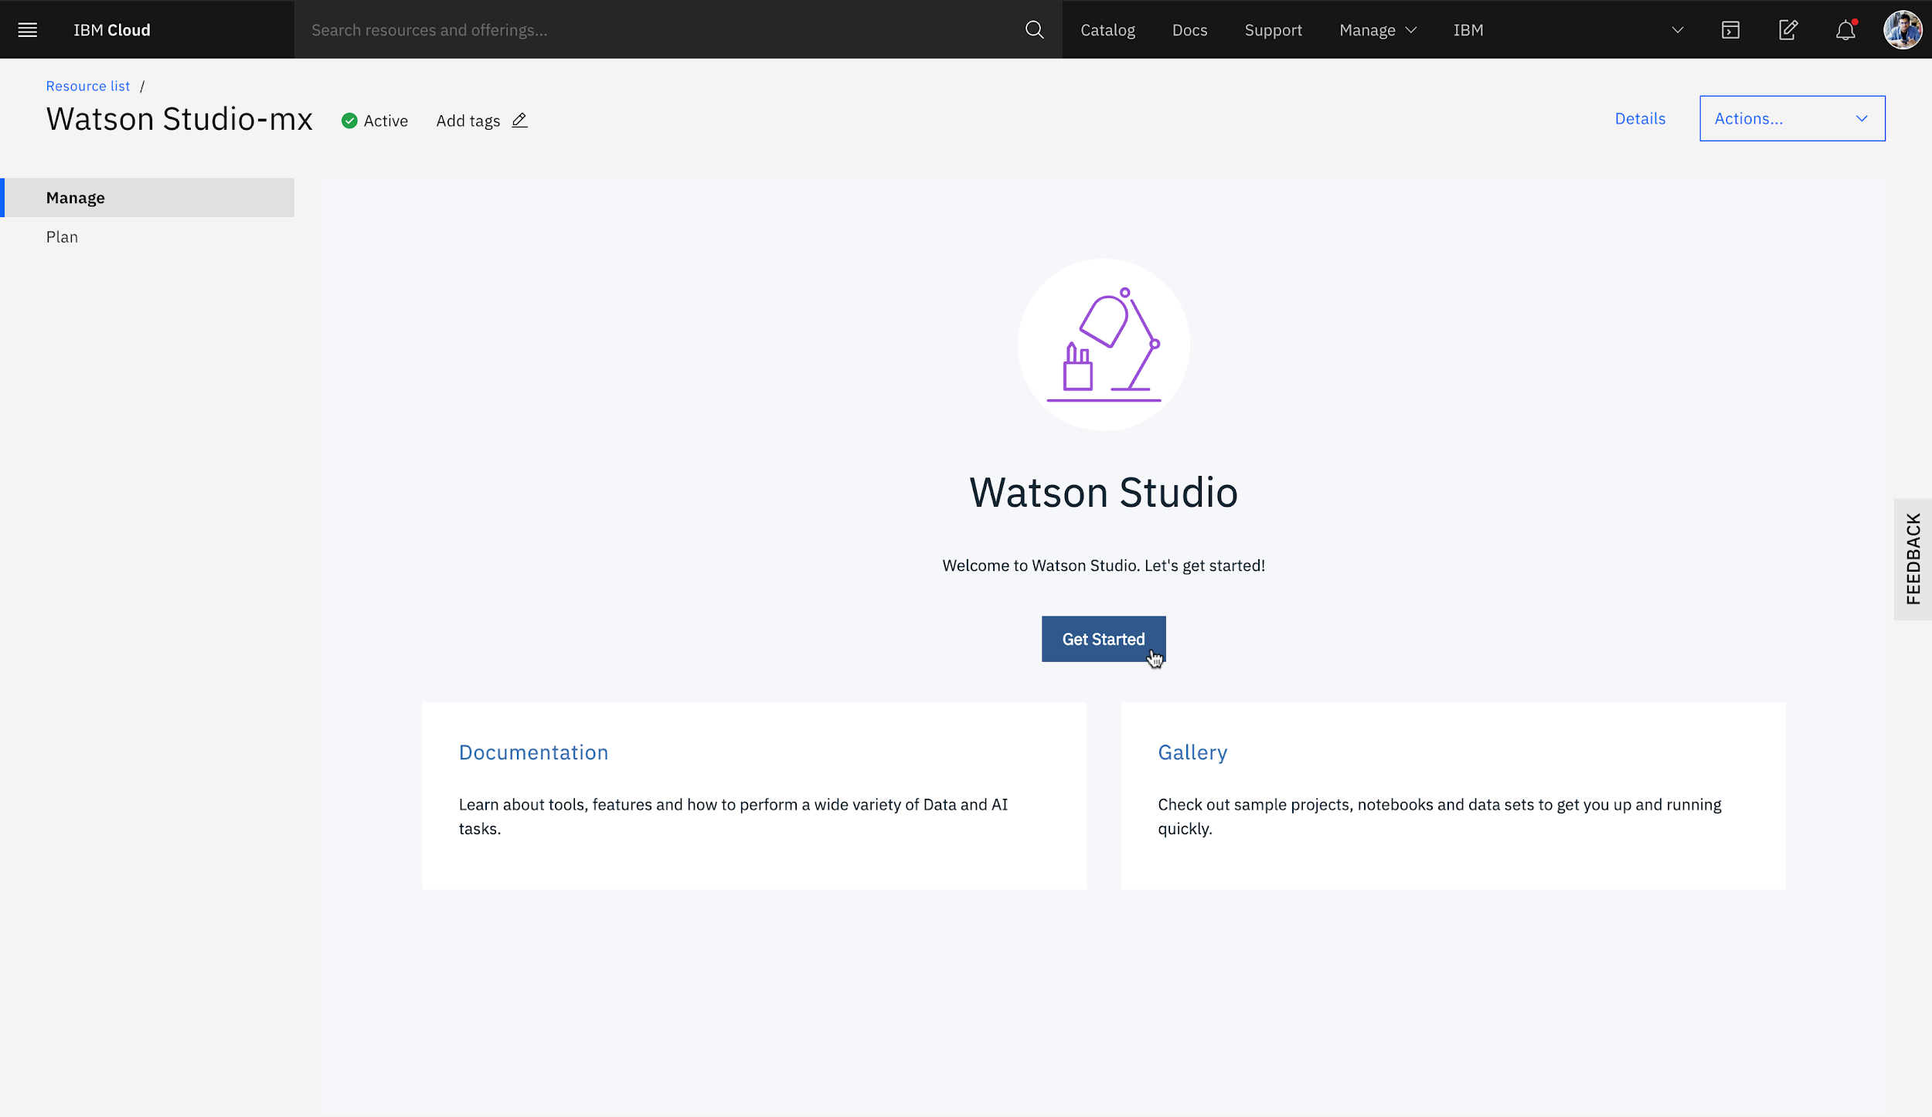
6. You will be redirected to IBM Cloud Pak for Data page.  
   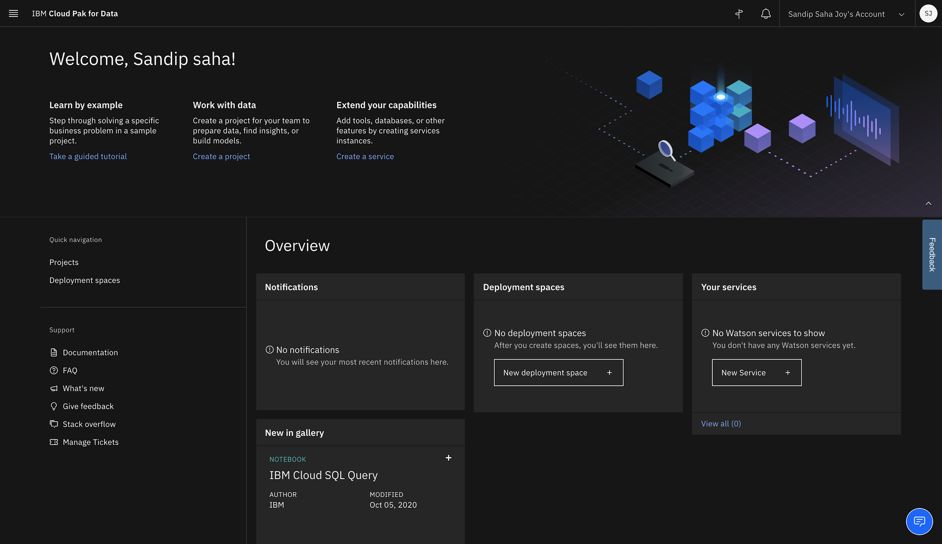

## Task B: Login to IBM Cloud Pak for Data to use Watson Studio

* If you just completed Task A, you will already be logged in, so skip Task B.

1. Go to [dataplatform.cloud.ibm.com](https://dataplatform.cloud.ibm.com/?utm_medium=Exinfluencer&utm_source=Exinfluencer&utm_content=000026UJ&utm_term=10006555&utm_id=NA-SkillsNetwork-wwwcourseraorg-SkillsNetworkCoursesIBMDA0321ENSkillsNetwork21426264-2021-01-01).
2. Enter your IBMid(the email ID you used to sign up for IBM Cloud), password and select a region, same one you used during Watson Studio service instance creation.  
   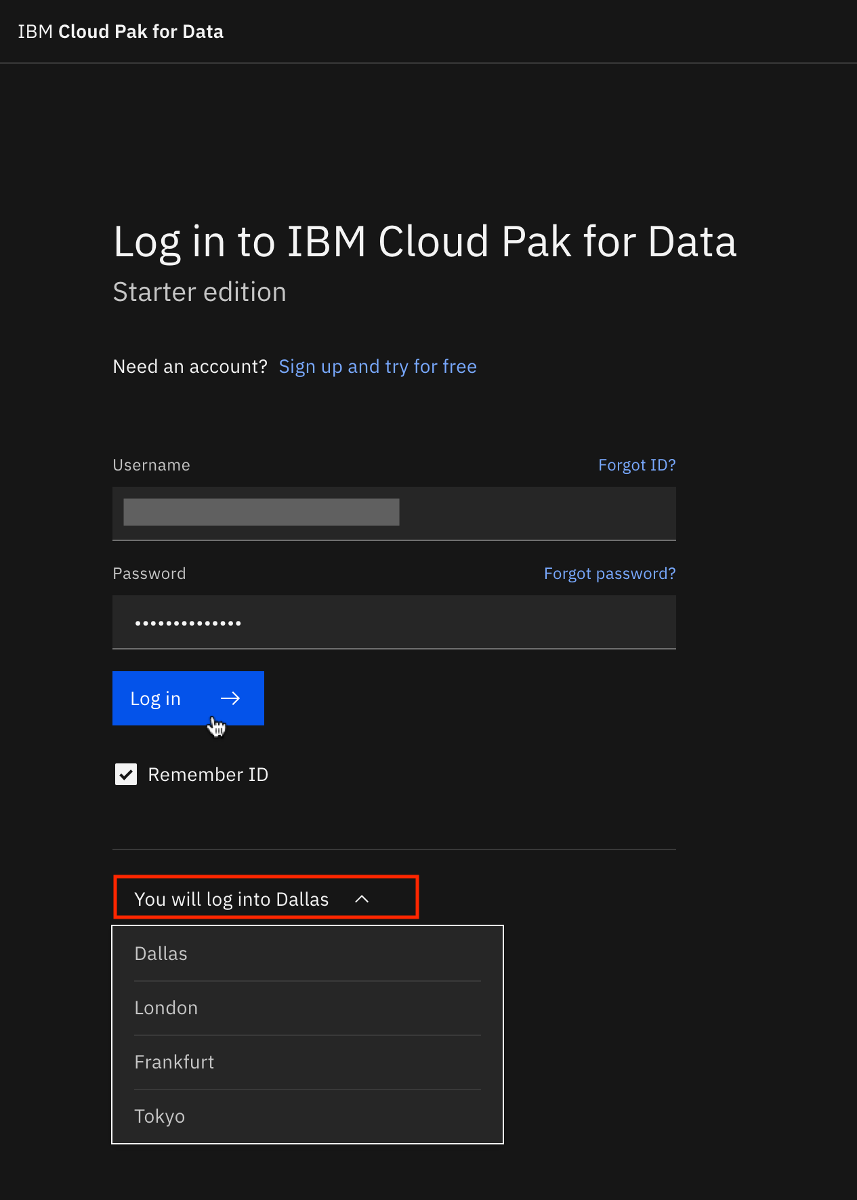
3. Click Go to IBM Cloud Pak for Data.  
   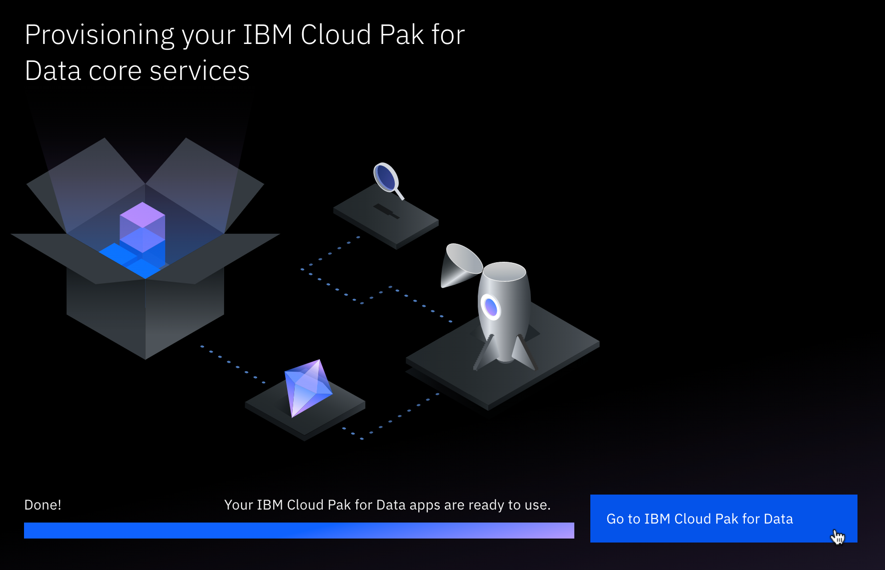
4. You have successfully logged in to the IBM Cloud Pak for Data platform.  
   

# Exercise 2: Creating a Project

In this exercise, you will create a project.

1. On the IBM Cloud Pak for Data welcome page, click Create a project.  
   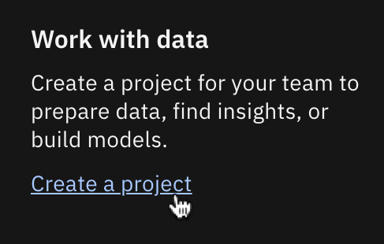
2. Click Create an empty project.  
   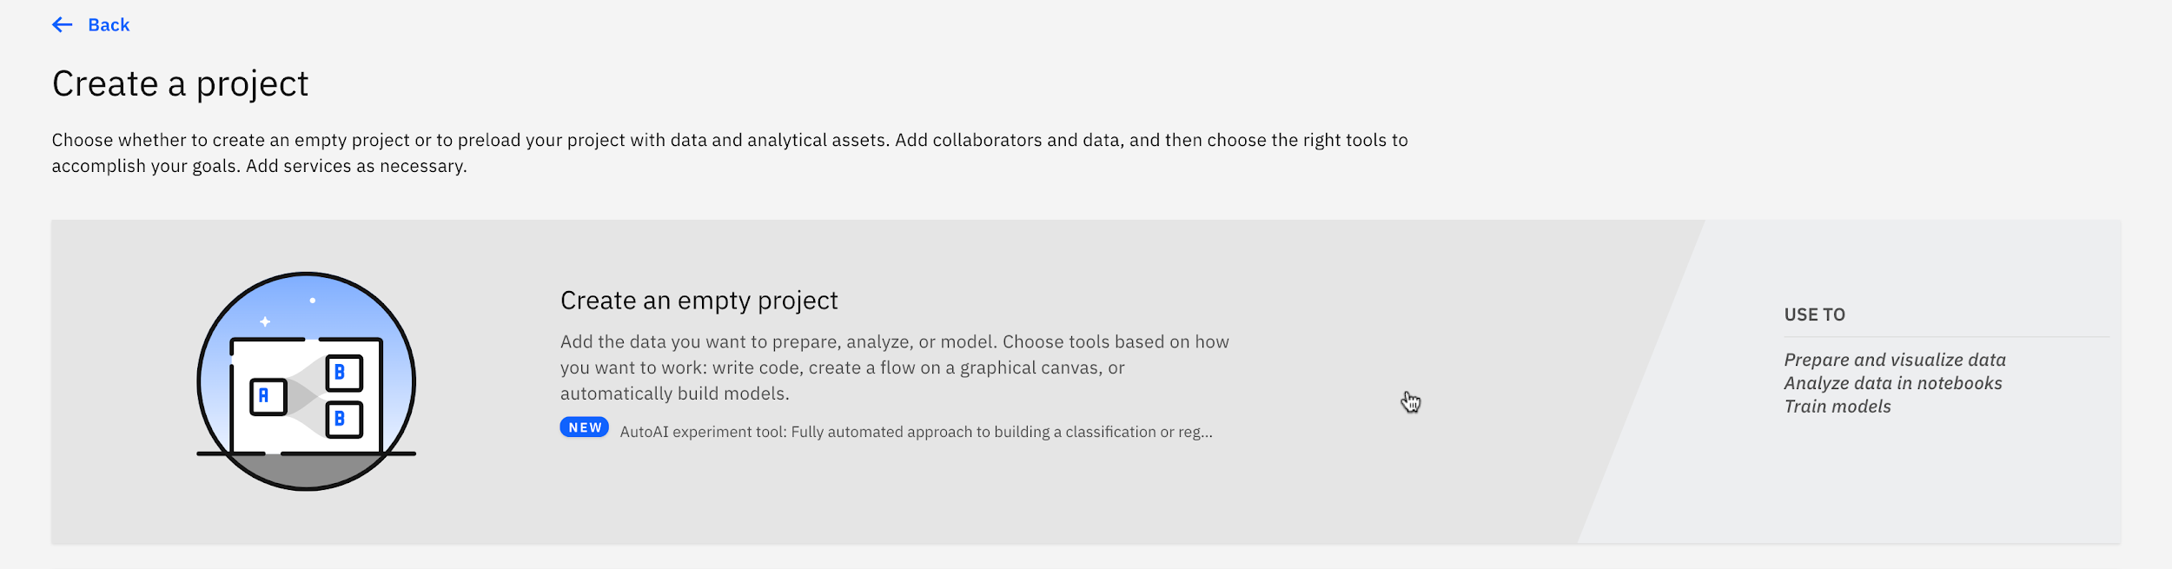
3. Write Capstone Project as name of the project and click Add on Select storage service if no storage service appears. If a storage appears, proceed to step 6 directly.  
   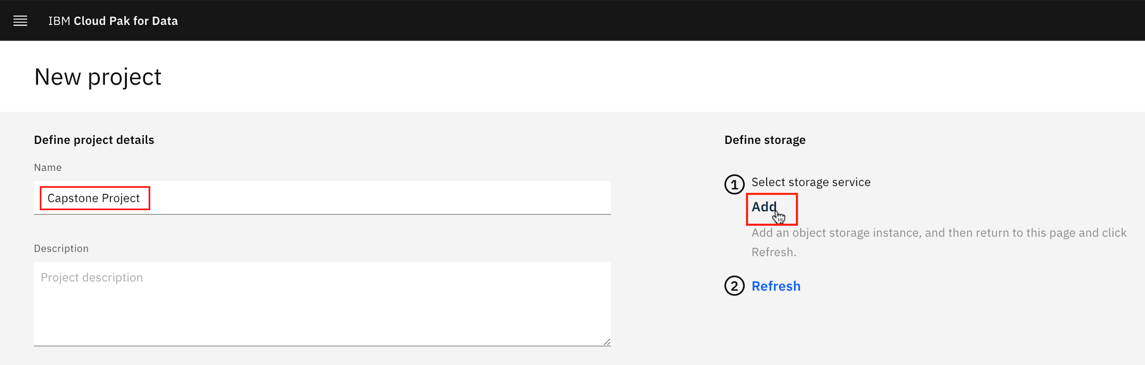
4. You will be redirected to a new page. On the Create tab, select Lite plan. Then click Create.  
   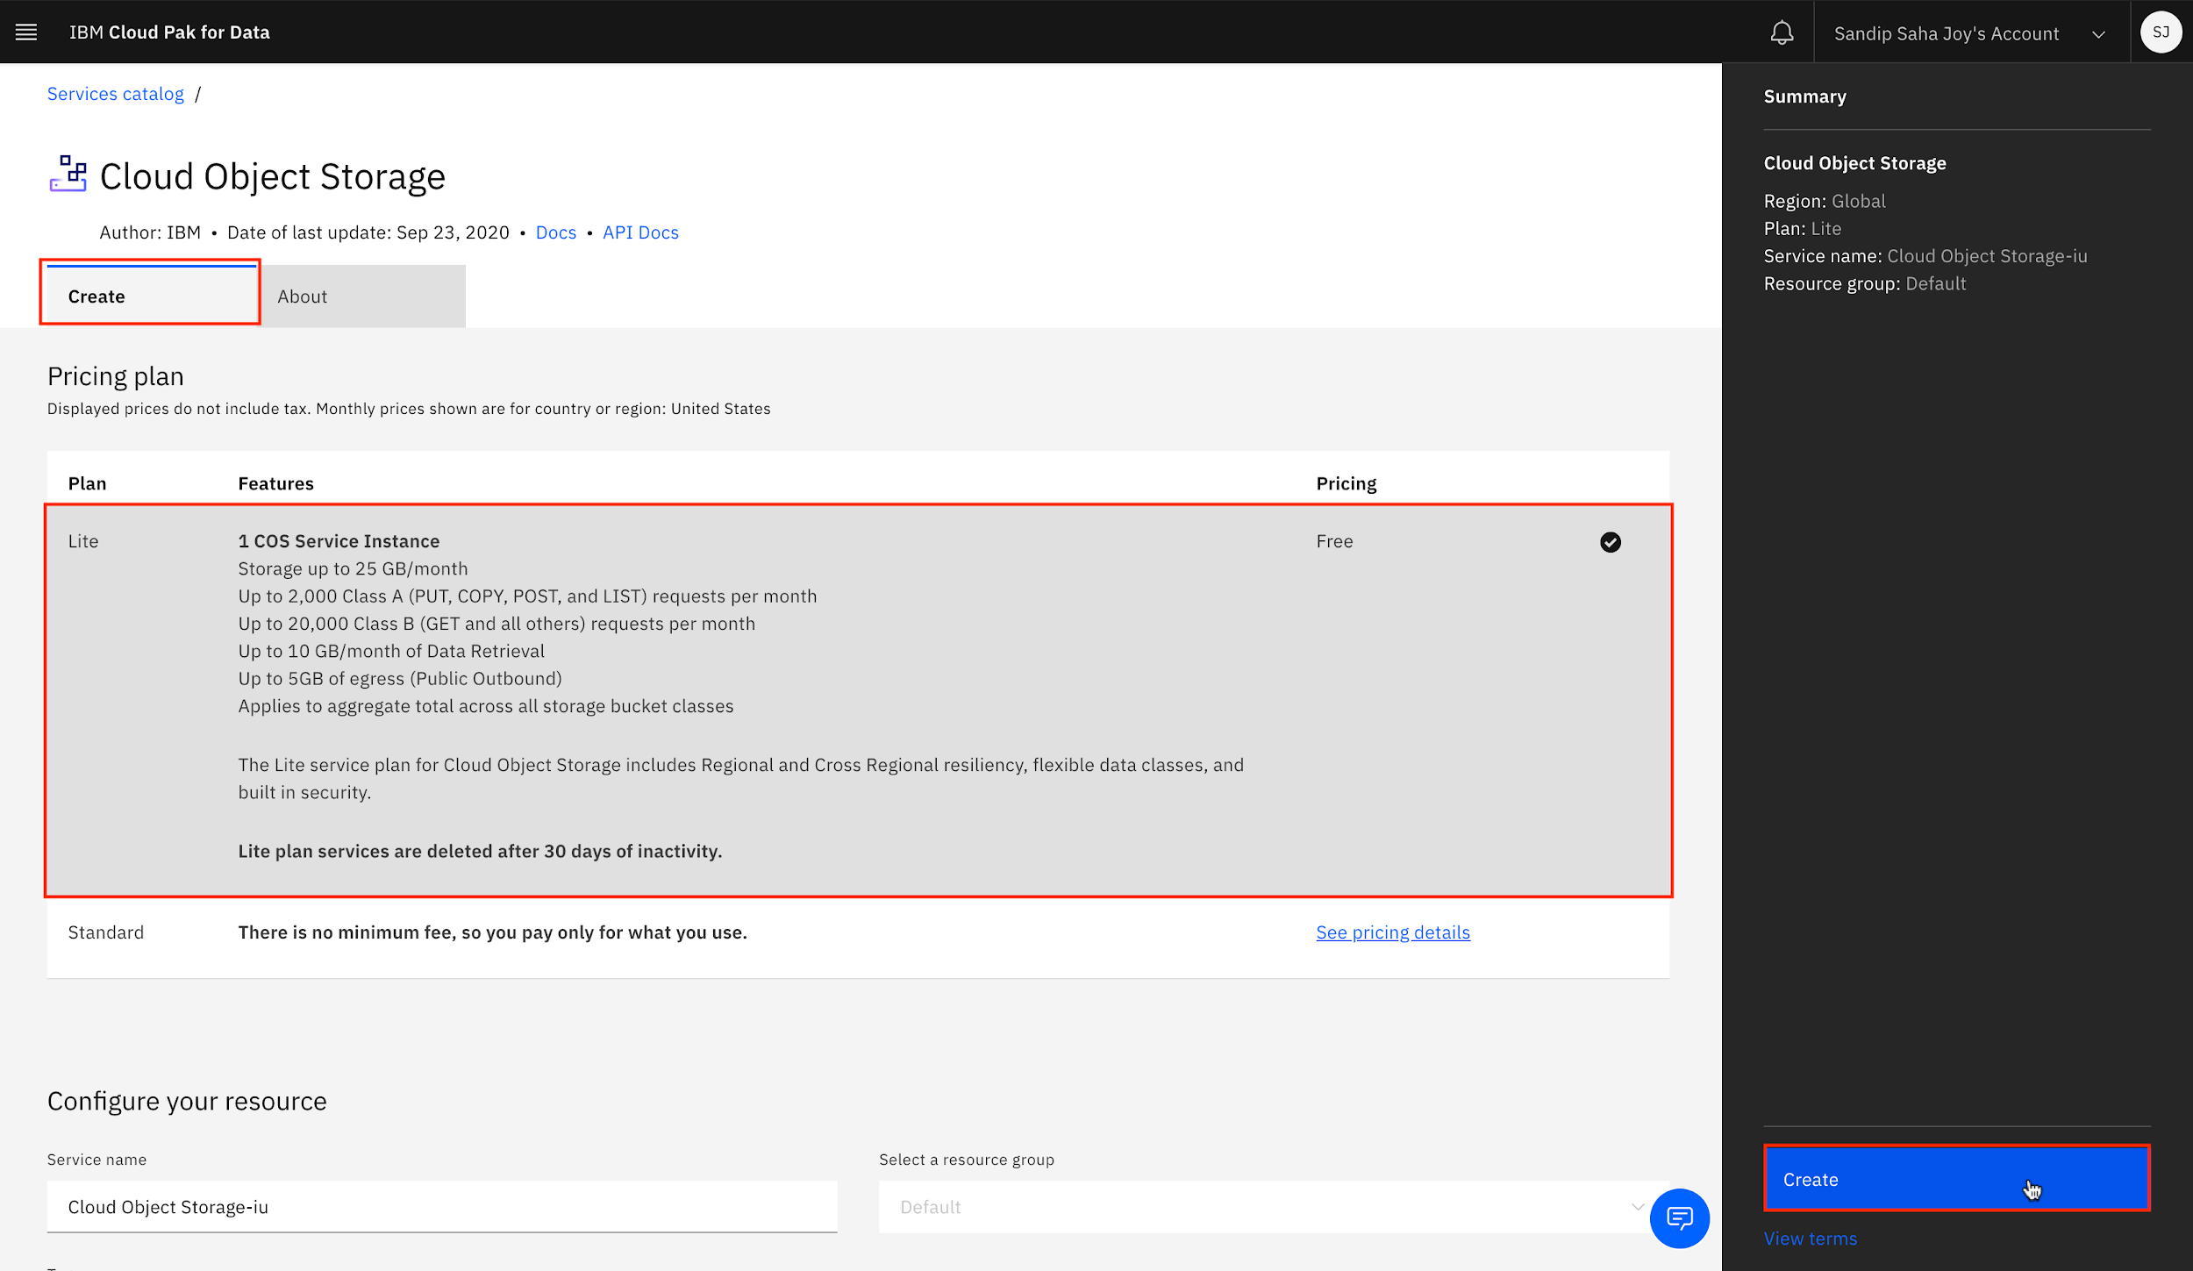
5. Now you will be redirected to the previous new project page. Click Refresh.  
   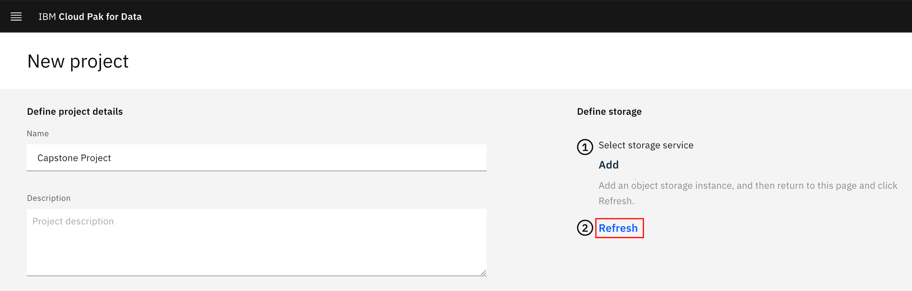
6. Once you see a storage service, click Create.  
   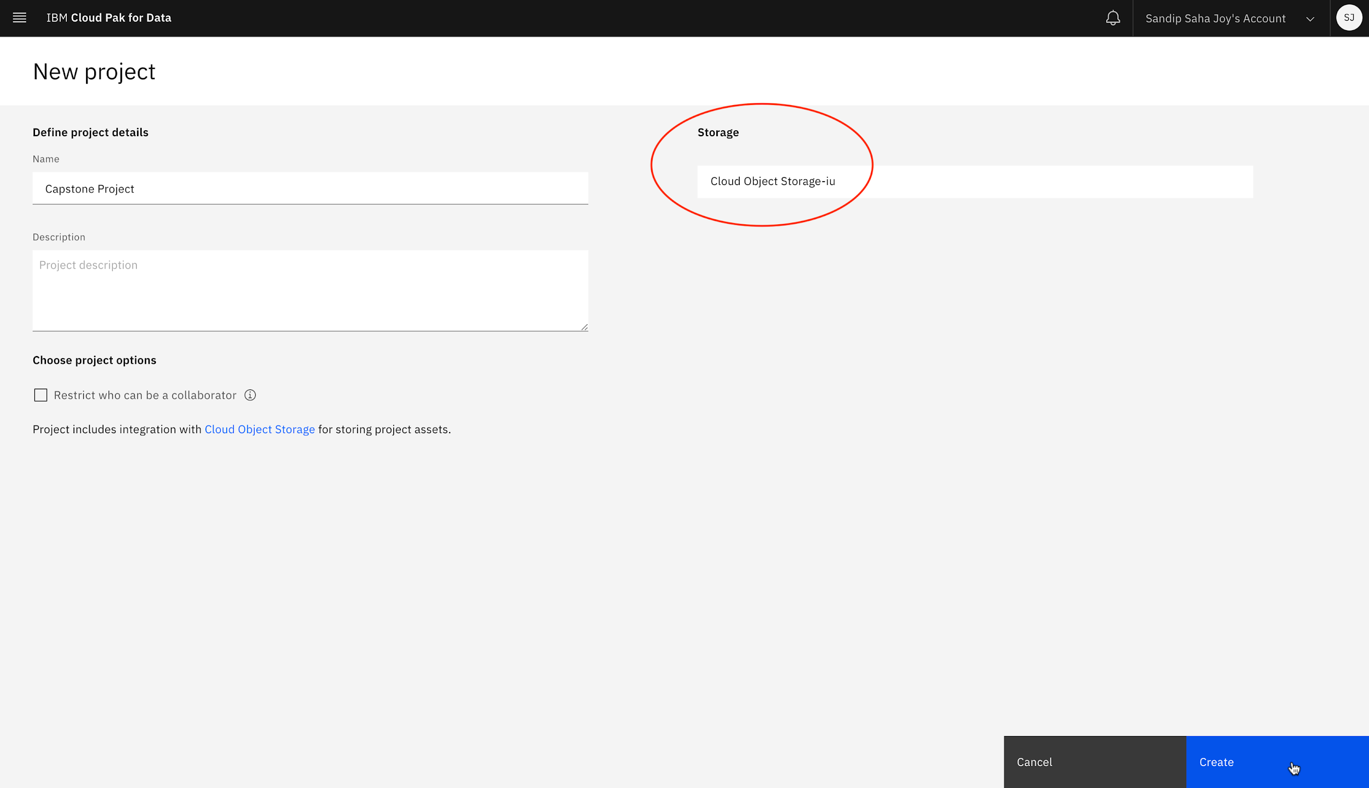
7. You have successfully created a project. Click IBM Cloud Pak for Data at the top left to go back to homepage.  
   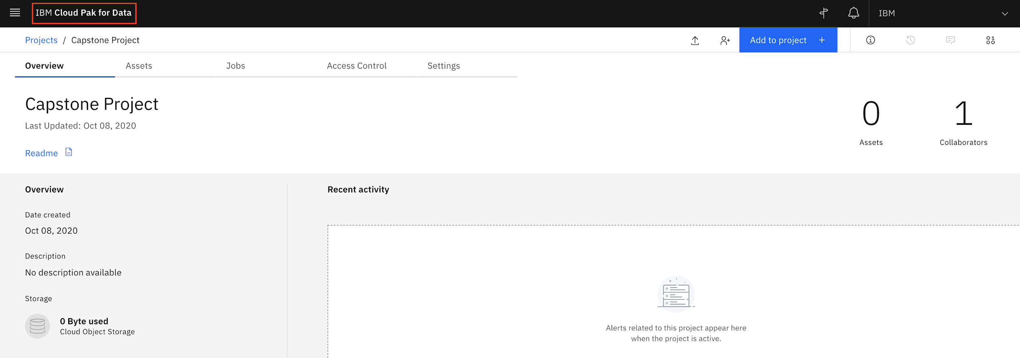

# Exercise 3: Adding a Jupyter Notebook to the Project

In this exercise, you will add an IPYNB Jupyter notebook to the Project you created.

1. From IBM Cloud Pak for Data homepage, click Projects under Quick navigation.  
   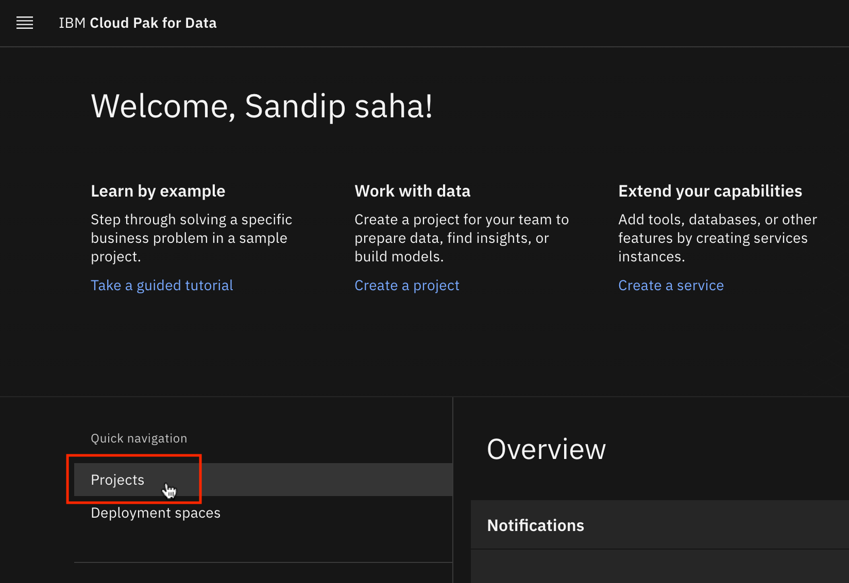
2. Select Capstone Project you created earlier.  
   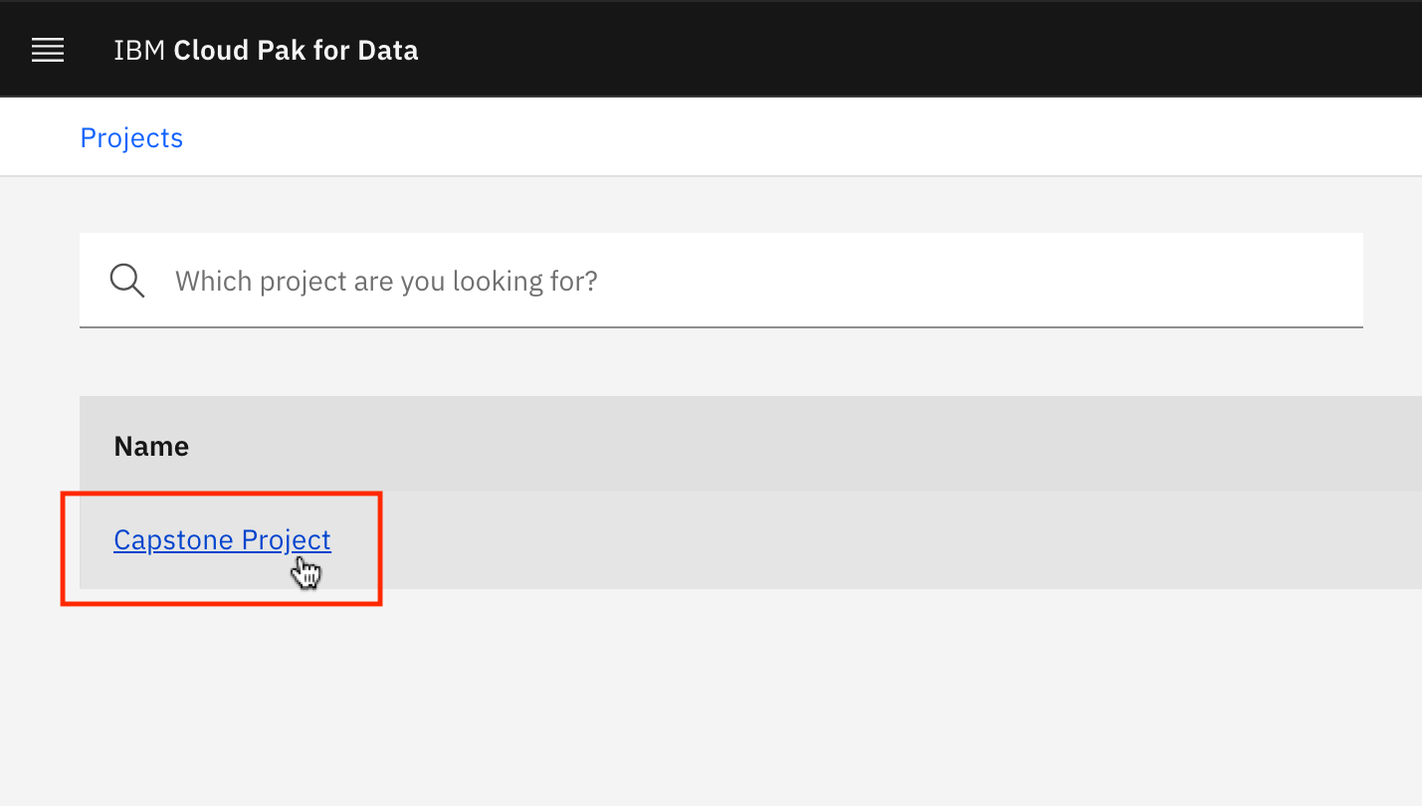
3. On the Overview page of Capstone Project project, click Add to project.  
   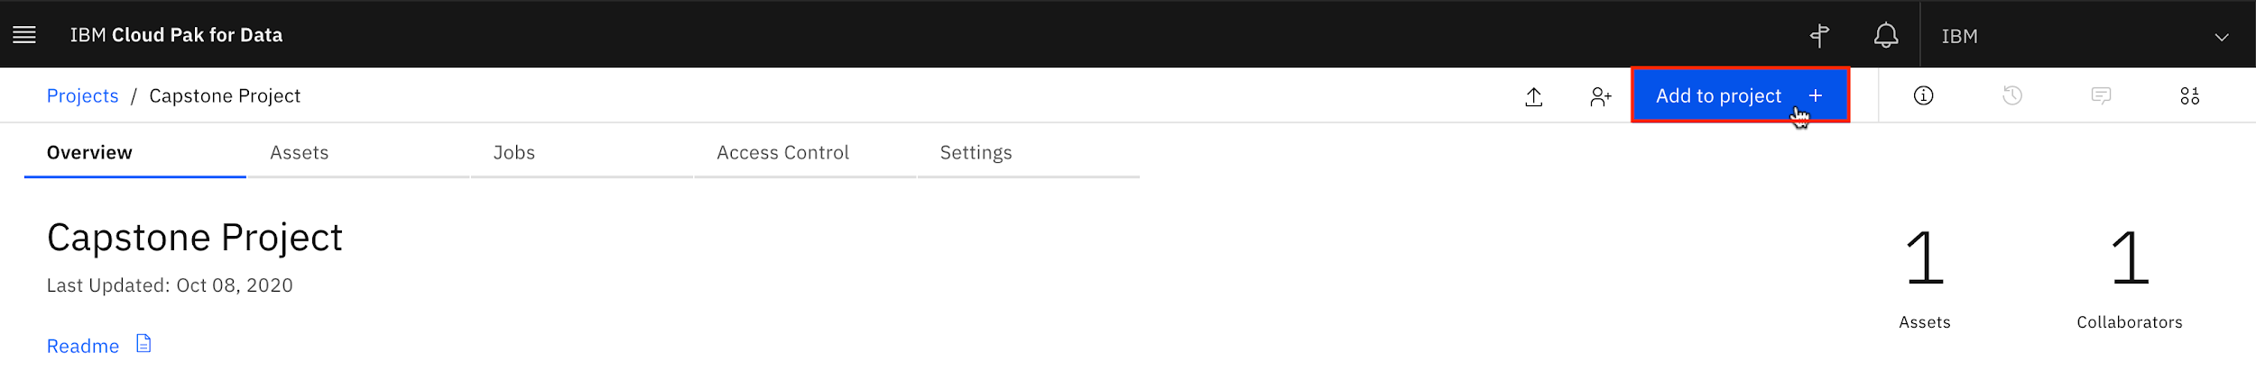
4. Select Notebook.  
   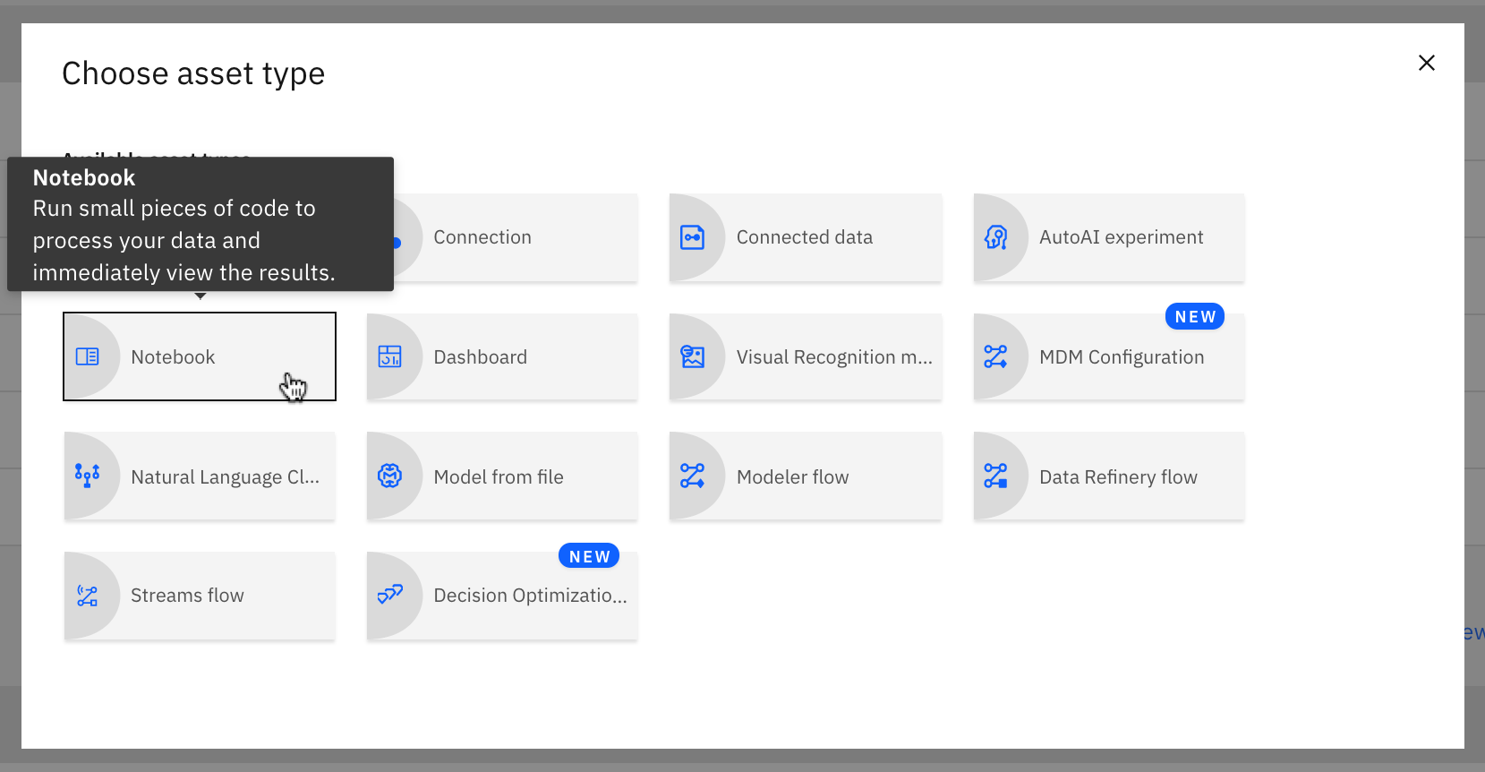
   * Right-click on this [Link](https://cf-courses-data.s3.us.cloud-object-storage.appdomain.cloud/IBM-DA0321EN-SkillsNetwork/labs/module%201/Sample%20Jupyter%20Notebook/sample-jupyter-notebook.ipynb?utm_medium=Exinfluencer&utm_source=Exinfluencer&utm_content=000026UJ&utm_term=10006555&utm_id=NA-SkillsNetwork-wwwcourseraorg-SkillsNetworkCoursesIBMDA0321ENSkillsNetwork21426264-2021-01-01) and copy the link address of the sample Jupyter notebook.
   * Under From URL tab, name the Notebook as Sample Jupyter Notebook. Then paste the link of the sample Jupyter notebook to Notebook URL you just copied.
5. 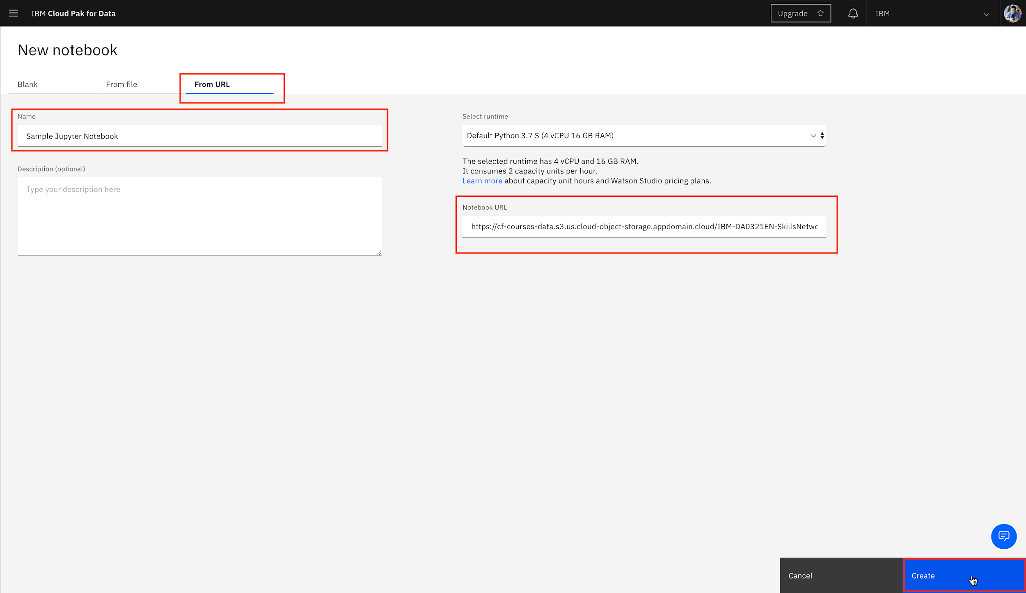
6. Wait until the notebook gets uploaded and become ready.  
   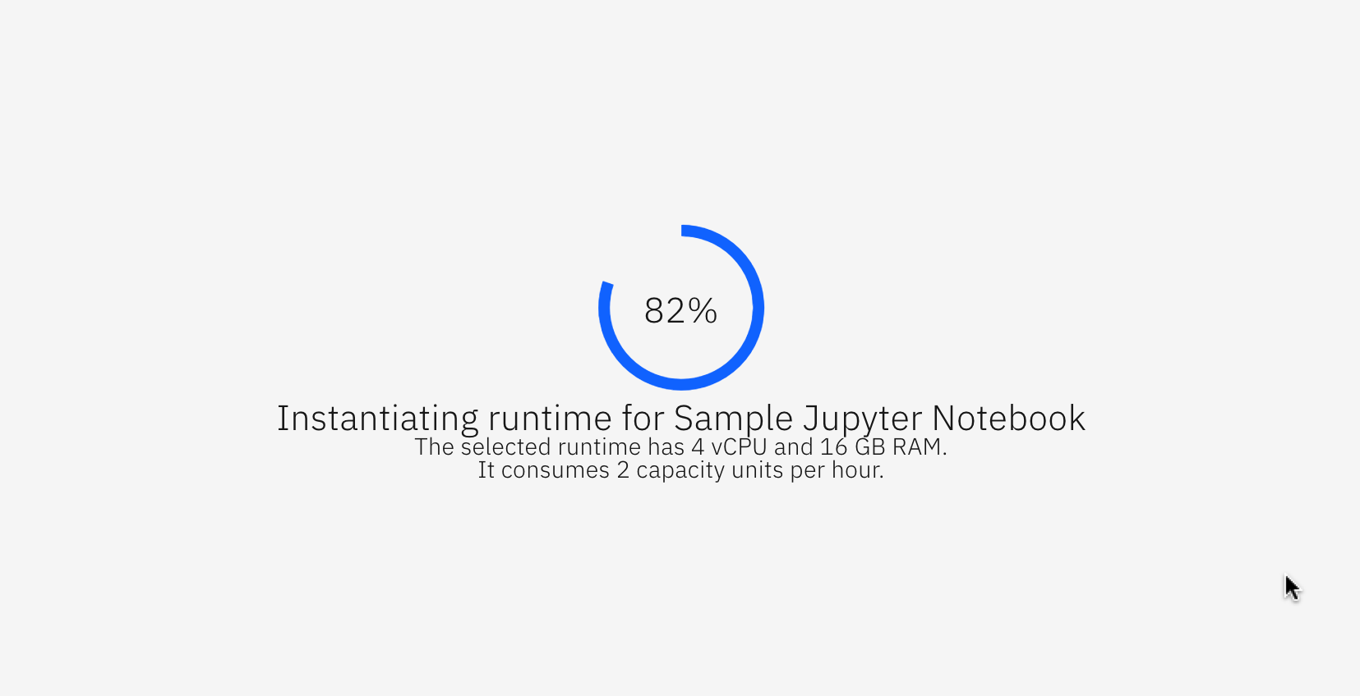
7. You have successfully added a Jupyter Notebook to the Project and opened it using Watson Studio. To share the notebook using permalink, click on the Share icon.  
   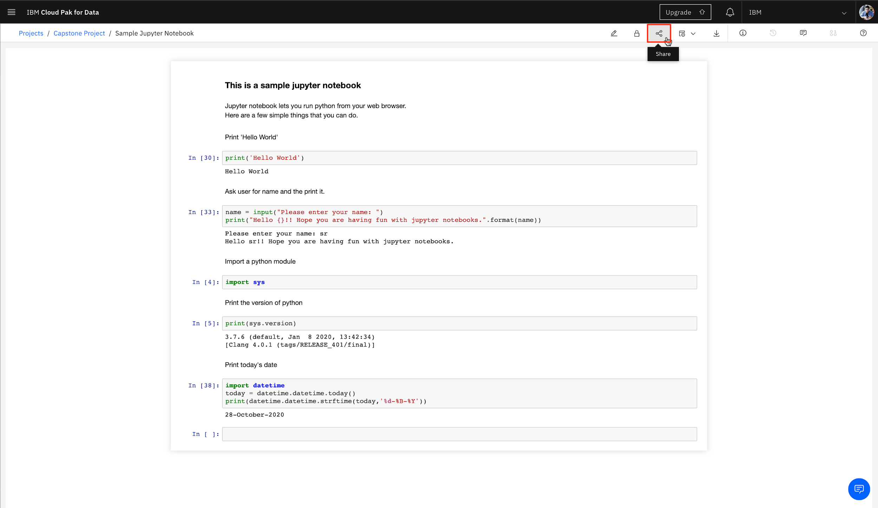
8. Click on the toggle button to turn on "Share with anyone who has the link". Select All content, including code from Cell content. Click on the copy link icon to copy the "Permalink to view notebook" and share the link if you need to share your work on the notebook. This link always points to the most recent saved version of the notebook.  
   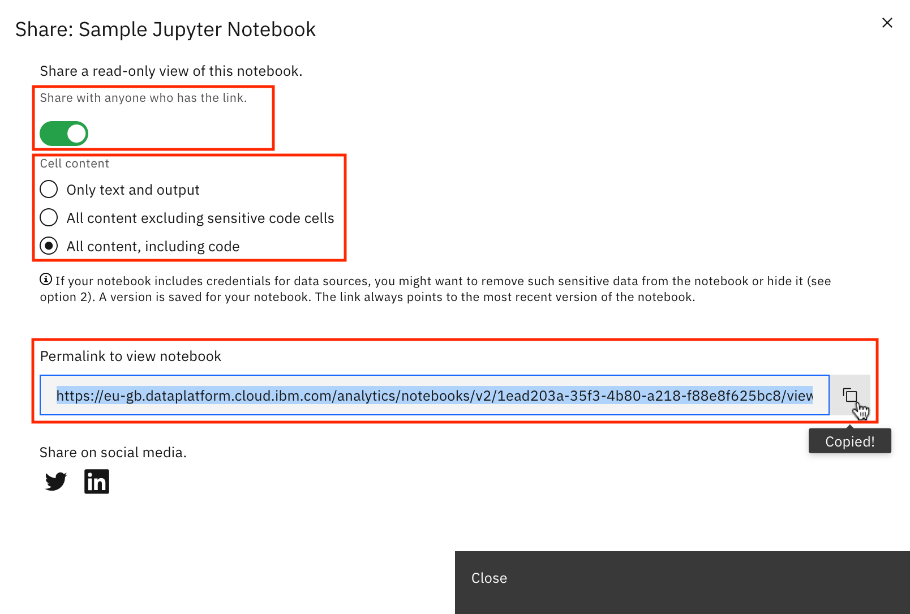

### Congratulations! You have completed this Lab.